9.
hashcat -a 0 hash phpbb.txt --force
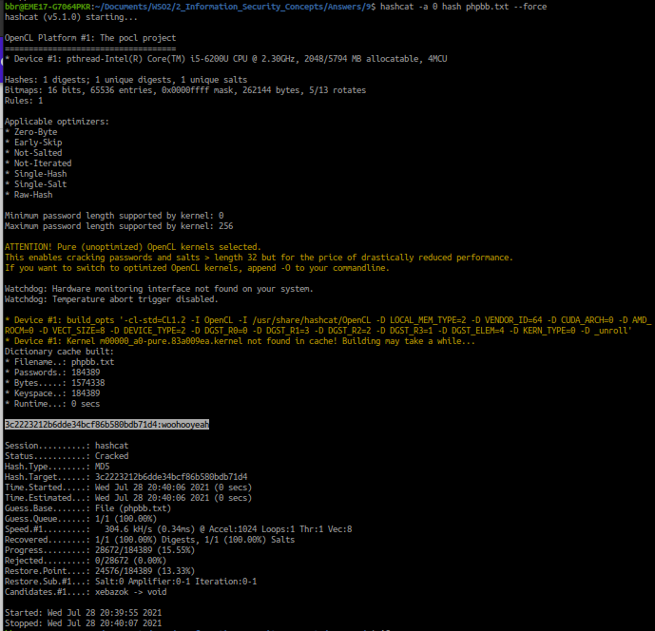
Craked value is : 3c2223212b6dde34bcf86b580bdb71d4:woohooyeah

